Abstract Factory Pattern

Abstract Factory patterns work around a super-factory which creates other factories. This factory is also called as factory of factories. This type of design pattern comes under creational pattern as this pattern provides one of the best ways to create an object.
In Abstract Factory pattern an interface is responsible for creating a factory of related objects without explicitly specifying their classes. Each generated factory can give the objects as per the Factory pattern.

Implementation
We are going to create a Shape and Color interfaces and concrete classes implementing these interfaces. We create an abstract factory class AbstractFactory as next step. Factory classes ShapeFactory and ColorFactoryare defined where each factory extends AbstractFactory. A factory creator/generator class FactoryProducer is created.
AbstractFactoryPatternDemo, our demo class uses FactoryProducer to get a AbstractFactory object. It will pass information (CIRCLE / RECTANGLE / SQUARE for Shape) to AbstractFactory to get the type of object it needs. It also passes information (RED / GREEN / BLUE for Color) to AbstractFactory to get the type of object it needs.
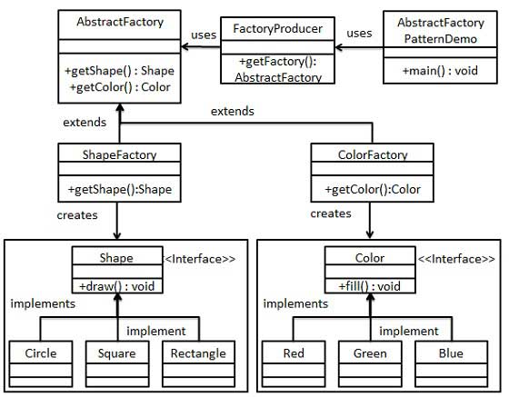

Step 1
Create an interface for Shapes.
Shape.java
public interface Shape {
void draw();
}

Step 2
Create concrete classes implementing the same interface.
Rectangle.java
public class Rectangle implements Shape {

@Override
public void draw() {
System.out.println("Inside Rectangle::draw() method.");
}
}
Square.java
public class Square implements Shape {

@Override
public void draw() {
System.out.println("Inside Square::draw() method.");
}
}
Circle.java
public class Circle implements Shape {

@Override
public void draw() {
System.out.println("Inside Circle::draw() method.");
}
}

Step 3
Create an interface for Colors.
Color.java
public interface Color {
void fill();
}

Step4
Create concrete classes implementing the same interface.
Red.java
public class Red implements Color {

@Override
public void fill() {
System.out.println("Inside Red::fill() method.");
}
}
Green.java
public class Green implements Color {

@Override
public void fill() {
System.out.println("Inside Green::fill() method.");
}
}
Blue.java
public class Blue implements Color {

@Override
public void fill() {
System.out.println("Inside Blue::fill() method.");
}
}

Step 5
Create an Abstract class to get factories for Color and Shape Objects.
AbstractFactory.java
public abstract class AbstractFactory {
abstract Color getColor(String color);
abstract Shape getShape(String shape) ;
}

Step 6
Create Factory classes extending AbstractFactory to generate object of concrete class based on given information.
ShapeFactory.java
public class ShapeFactory extends AbstractFactory {

@Override
public Shape getShape(String shapeType){

if(shapeType == null){
return null;
}

if(shapeType.equalsIgnoreCase("CIRCLE")){
return new Circle();

}else if(shapeType.equalsIgnoreCase("RECTANGLE")){
return new Rectangle();

}else if(shapeType.equalsIgnoreCase("SQUARE")){
return new Square();
}

return null;
}

@Override
Color getColor(String color) {
return null;
}
}
ColorFactory.java
public class ColorFactory extends AbstractFactory {

@Override
public Shape getShape(String shapeType){
return null;
}

@Override
Color getColor(String color) {

if(color == null){
return null;
}

if(color.equalsIgnoreCase("RED")){
return new Red();

}else if(color.equalsIgnoreCase("GREEN")){
return new Green();

}else if(color.equalsIgnoreCase("BLUE")){
return new Blue();
}

return null;
}
}

Step 7
Create a Factory generator/producer class to get factories by passing an information such as Shape or Color
FactoryProducer.java
public class FactoryProducer {
public static AbstractFactory getFactory(String choice){

if(choice.equalsIgnoreCase("SHAPE")){
return new ShapeFactory();

}else if(choice.equalsIgnoreCase("COLOR")){
return new ColorFactory();
}

return null;
}
}

Step 8
Use the FactoryProducer to get AbstractFactory in order to get factories of concrete classes by passing an information such as type.
AbstractFactoryPatternDemo.java
public class AbstractFactoryPatternDemo {
public static void main(String[] args) {

//get shape factory
AbstractFactory shapeFactory = FactoryProducer.getFactory("SHAPE");

//get an object of Shape Circle
Shape shape1 = shapeFactory.getShape("CIRCLE");

//call draw method of Shape Circle
shape1.draw();

//get an object of Shape Rectangle
Shape shape2 = shapeFactory.getShape("RECTANGLE");

//call draw method of Shape Rectangle
shape2.draw();

//get an object of Shape Square
Shape shape3 = shapeFactory.getShape("SQUARE");

//call draw method of Shape Square
shape3.draw();

//get color factory
AbstractFactory colorFactory = FactoryProducer.getFactory("COLOR");

//get an object of Color Red
Color color1 = colorFactory.getColor("RED");

//call fill method of Red
color1.fill();

//get an object of Color Green
Color color2 = colorFactory.getColor("Green");

//call fill method of Green
color2.fill();

//get an object of Color Blue
Color color3 = colorFactory.getColor("BLUE");

//call fill method of Color Blue
color3.fill();
}
}

Step 9
Verify the output.
Inside Circle::draw() method.
Inside Rectangle::draw() method.
Inside Square::draw() method.
Inside Red::fill() method.
Inside Green::fill() method.
Inside Blue::fill() method.

